Social Action at Newcastle Reform Synagogue
The generous response of the community to recent Mitzvah Days and a long history of support to various charities provide a sound basis for the establishment of social action at NRS.
The rationale for this approach is that if the community can focus on a particular group and establish a pattern of giving throughout the year, then this would be a much more effective way of identifying and addressing need
A small group has undertaken to find out more about agencies working with asylum seekers and refugees and to feed the findings back to Council.
The four projects below are those that NRS would like the community to support and on Mitzvah Day we hope you will attend NRS and hear directly from representatives of these Charities.
Visit to The Hub Drop In (Westgate Baptist Church, 366 Westgate Rd, NE4 6NX) 2.2.18
Joan and Peter Forrest came to NRS on Mitzvah Day to talk about their involvement with asylum seekers and refugees, but we knew we also needed to spend time at the Drop In they run. (Jo has been a volunteer there for some years)
As it was half term, it was slightly less busy but there were about 60 there including a number of children. The Rights Advisors had full lists so there was no opportunity to meet with them. Those who come are different ages, backgrounds and have varying needs. However, they all appreciate the chance to chat to the volunteers and to each other. Some of the younger children are happy to have paper and crayons and there is table football, pool and table tennis available for all.
The food is basic-Iceland pizzas, fresh fruit and biscuits along with hot and cold drinks. Any donated goods (clothing, household items) are laid on a side shelf, any stuff which is not taken is passed to local charities as there is very limited storage. If someone identifies a specific item needed, then every effort is made to find it (eg a TV, a fridge, a duvet, a sleeping bag, baby goods). Toiletries are sometimes donated and are always welcome.
Each week, there are several people who are homeless and if lucky, will be sofa surfing rather than sleeping in the park. Small cash payments are given, regularly in total around £100 per week. People entitled to £37.75 per week are given this money on a card which means that any extra expenditure beyond supermarket shopping is hard to meet eg bus fares, food from an independent shop

Visit to Comfrey Project (Windmill Hills Centre, Chester Place, NE8 1QB) 14.2.18
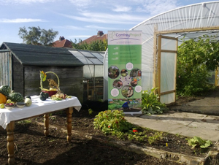
We knew this project was based around gardening but knew little else about it. The building is an old nursery school in Gateshead and has a good central space, with smaller rooms opening off and of course a kitchen. The day we visited was bitterly cold so we did not explore outside but plan to return in better weather!
Last October the project hit a funding crisis and had to make redundant the employed members of staff. These people continued to volunteer and the project remained open one session a week. They received many offers of practical and financial support and have now been able to pay the staff and open for three days a week.

The day we visited there were people there from all age groups and many different countries. Sewing machines were available, and there was an array of creative materials for children as well as a volunteer to assist.
People obviously enjoyed chatting with each other and with the staff and volunteers
Lunch was a highlight, cooked from scratch in the kitchen by some people attending, with volunteers. Everyone ate in the main hall and it felt good and tasted incredible!
We were privileged to have a good session with Jo Price, the manager. It appears the project opens three days weekly. While the focus is on growing fruit and vegetables, in the past few years, the work has expanded to include winter sessions in cooking, horticulture and arts and crafts. The project runs two other sites, namely Walkergate and Moorside allotments.
Obviously, we were there on a cold winter`s day but the project would feel very different in the summer months. The polytunnel is used to grow a good supply of vegetables which are used for lunches and for participants to take away
Those who attend have been referred by a range of agencies, GP`s etc on the basis of concerns about mental health. One of the essential costs of the project is payments made to cover travel.
Although Gateshead Council have been instrumental in ensuring that Comfrey has a suitable site, we were told that at this point there is some uncertainty about the future as it is possible the site could be sold for building.
The project welcomes people across the area (ie not limited to Gateshead) and it places emphasis on its cooperation with other agencies eg North East Refugee Service, Freedom from Torture, local Food Bank and churches.

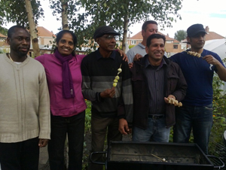
The Comfrey Project is keen to attract volunteers to help in their work. They are interested in people with gardening or cookery skills, or financial and admin skills.

Visit to Freedom from Torture (FfT) – 1-3, City Road, Newcastle Upon Tyne, NE1 2AF – 21.02.18

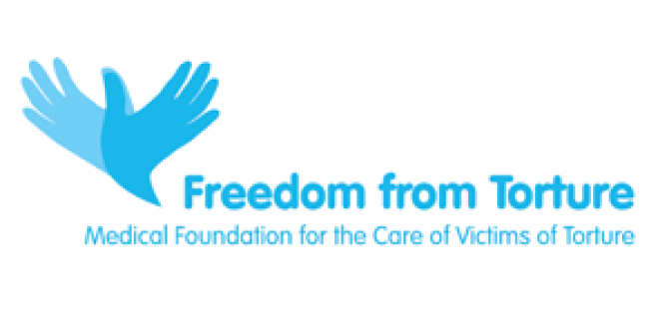

Freedom from Torture is a national charity that has centres in Birmingham, Glasgow, London, Manchester and Newcastle. The north east branch covers Cleveland, County Durham, Cumbria (Carlisle), Northumberland, Tyne & Wear, including: Darlington, Durham, Gateshead, Hartlepool, Middleborough, Newcastle Upon Tyne, North Shields, Redcar, South Shields, Stockton on Tees, Sunderland and Wallsend.

We met Eileen Brady, Social Worker and Carolyn Law, psychologist, at the Crisis Café, below the office. This, too is a great venue – a café and meeting space, run to support people in crisis, including the homeless of Newcastle. Eileen outlined the activities FfToffer here in the North East, which include;
Welfare casework
Legal support
Psychological therapy
Groups - allotment, cooking, yoga, men's group, women's group.
Medical assessments with a GP
Eileen told us that the allotment group will begin again in the Spring and is run in conjunction with the Comfrey Project. The Men’s group is a new initiative and is designed to lessen clients’ isolation and give them access to low/no cost activities in Newcastle. As with the Comfrey Project, clients are given their fares to and from their homes. There is a new cooking group, which is proving very popular with the clients.
Carolyn (and another two therapists) offer therapy to the victims of torture. All clients are referred, and therapy is on a one to one basis, often including an interpreter. Carolyn explained how important it is to use the same interpreter for each client, as building up a relationship of trust is essential when working with individuals who have been so traumatised. The criteria is that the victims have to have experienced torture ‘by a state actor’. There is no time limit to the therapy offered, which is usually around 3 years. The majority of those referred are men, but there are some women, mainly from Teeside and who have families. A designated doctor is attached to the charity and there are several volunteer doctors who also give their time offering examinations and writing reports. There are 9 members of the team working into the project on a sessional basis.
Any financial funding would go to the London office of this national charity, but donations can be received in kind or for a specific item – e.g. travel permits.

Visit to West End Refugee Service (WERS) -West End Refugee Service St Philip’s Vicarage St Philip’s Close Arthur’s Hill Newcastle upon Tyne NE4 5JE.
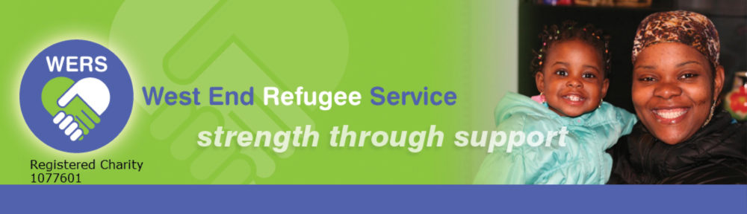

We went to meet the two women, Lindsay and Helen who had set up WERS 19 years ago. It is an organization that offers practical help, advice and advocacy through daily drop-in advice sessions, run by WERS’ multi-lingual support worker and trained volunteers. WERS also offers home visits for those who find it difficult to visit WERS’ offices, a clothing store, where good quality second-hand clothing and household items are offered free of charge and a Hardship Fund, providing emergency payments to clients in extreme need. Emotional support is offered through the Befriending Scheme, the only designated service for refugees and asylum seekers in the city. An extensive awareness-raising, education and training programme addresses the need for accurate information about asylum seekers and refugees and challenges the still prevalent negativity surrounding asylum seekers and refugees.
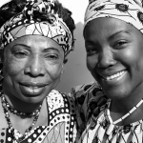
WERS’ volunteer program offers a wide range of volunteering opportunities: befriending, support work, outreach casework, working in the Clothing Store, admin support and gardening. WERS currently has 50 volunteers whose work is highly valued and significantly enhances the work of the charity.
Hundreds of clients are helped in different ways each year…
• There were 5,953 contact episodes at the daily drop-in advice sessions run by the support workers (5,402 last year)
• 562 clients received advice and support in many areas including housing, health, education and hardship (520 last year)
• 207 destitute clients were supported by the Hardship Fund for varying lengths of time – some throughout the year (191 last year)
• £106,527 was given out to clients from the Hardship Fund (£94,891 last year)
• An average of 3,622 items of clothing were given out each month to clients from the Clothing Store (2,755 items last year)
• 23 clients and their families benefited from having regular visits from their befrienders
• The awareness-raising programme has reached 2,416 community members of all ages during the year (1,866 last year)

These are the four charities Newcastle Reform Synagogue hopes to support via the newly established Social Action Group, which is to be launched officially, on Mitzvah Day 2018.

